|  |  |  |
| --- | --- | --- |
| **Requirement Tag** | **Requirement Description** | **Comments** |
| VSTR/01 | Read a line of text as a single string from command line |  |
| VSTR/02 | Create a class named “Wordset” with members as below vector <string> vlist;  int addmember(string s) - add given string s to vlist int deletemember(string s) – search and delete the given string s from vlist void displaylist() – iterate the vlist and display all its contents |  |
| VSTR/03 | Parse the command line arguments, extract words and store them in vlist |  |
| VSTR/04 | Prompt the user for a word to search and delete, then call deletemember if found |  |
| VSTR/05 | Display the contents of vector. |  |
| VSTR/06 | Empty the vlist and display the size of vlist |  |
| VSTR/07 | For every unque word stored in vector, get its frequency and display. | Hint: Use a map with key as string and frequency as value |

**VSTR/01:**

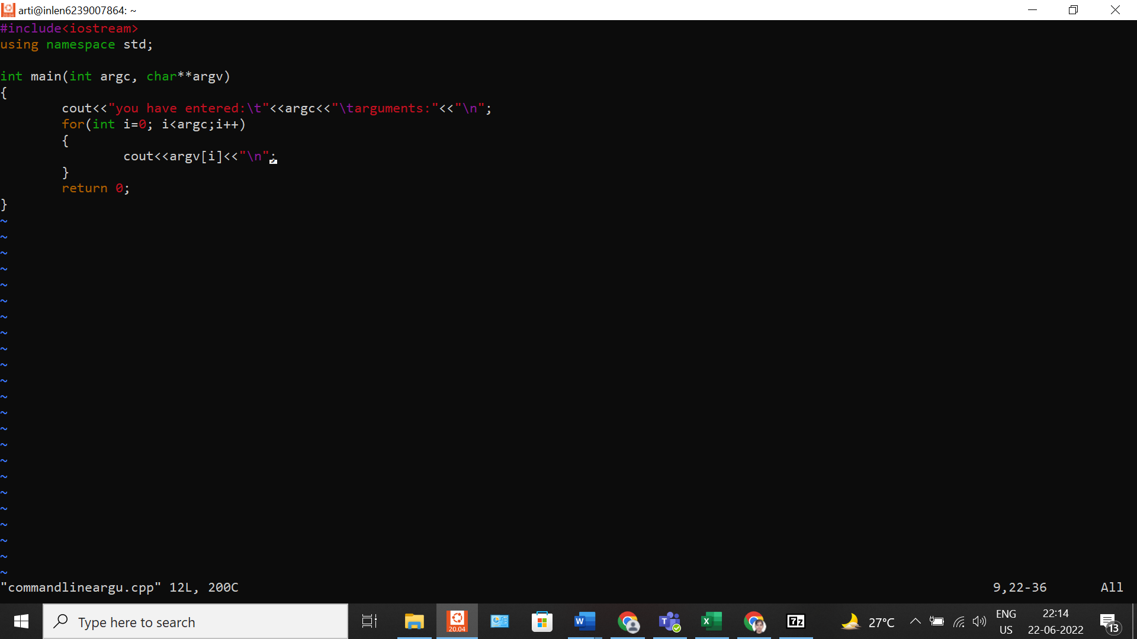

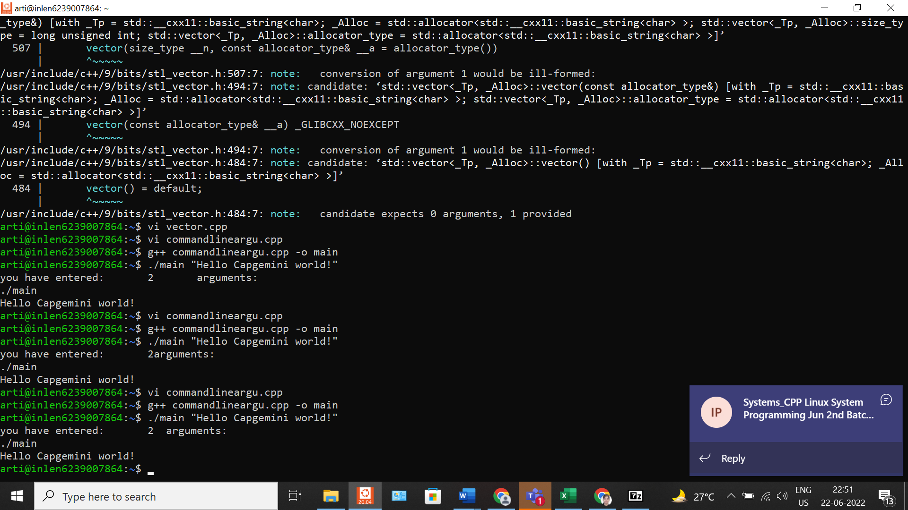

**VSTR/02:**

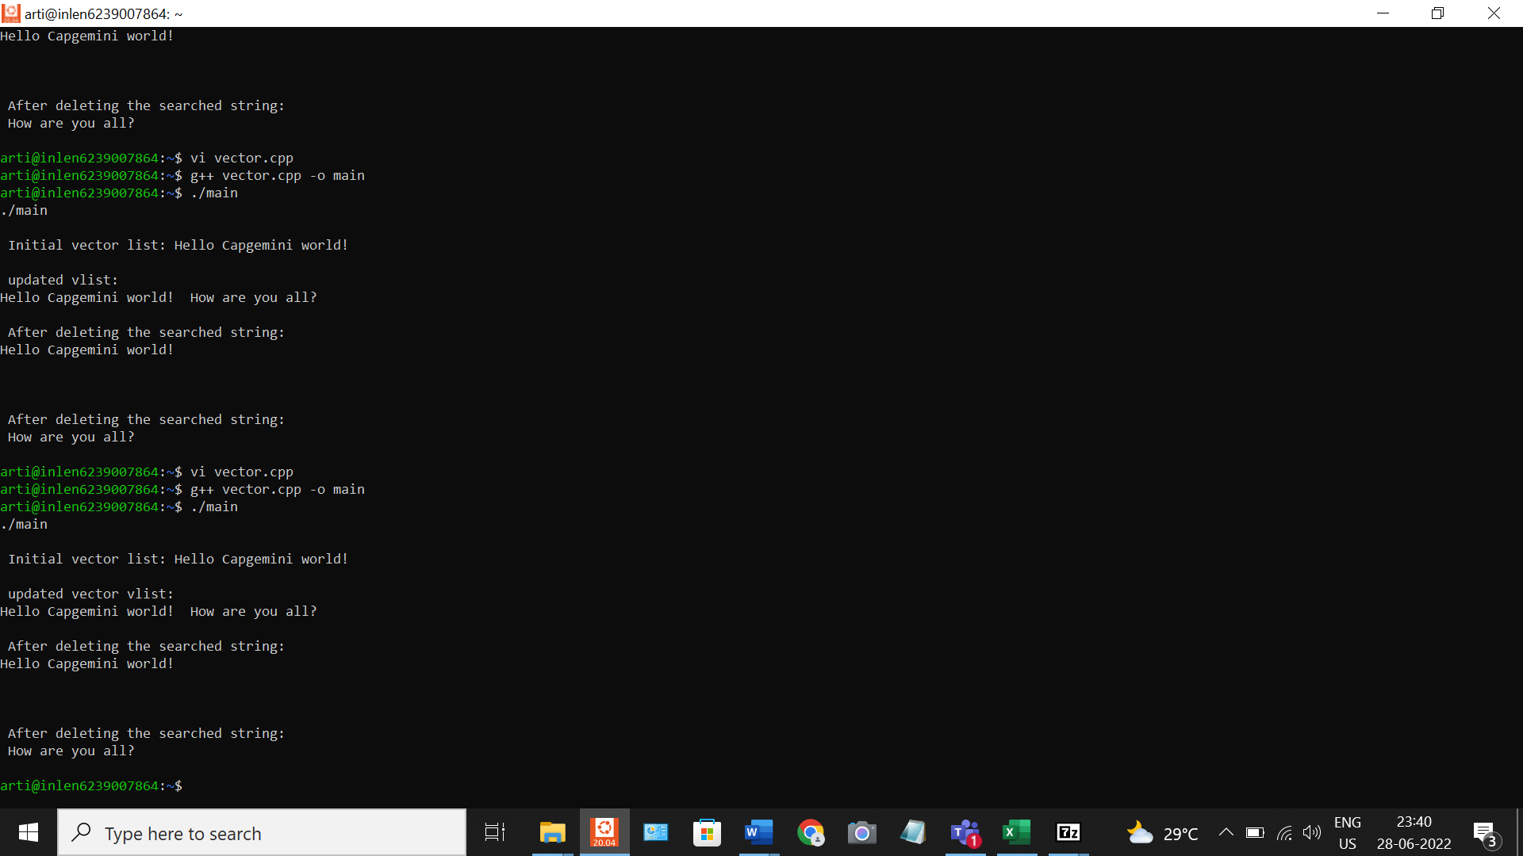

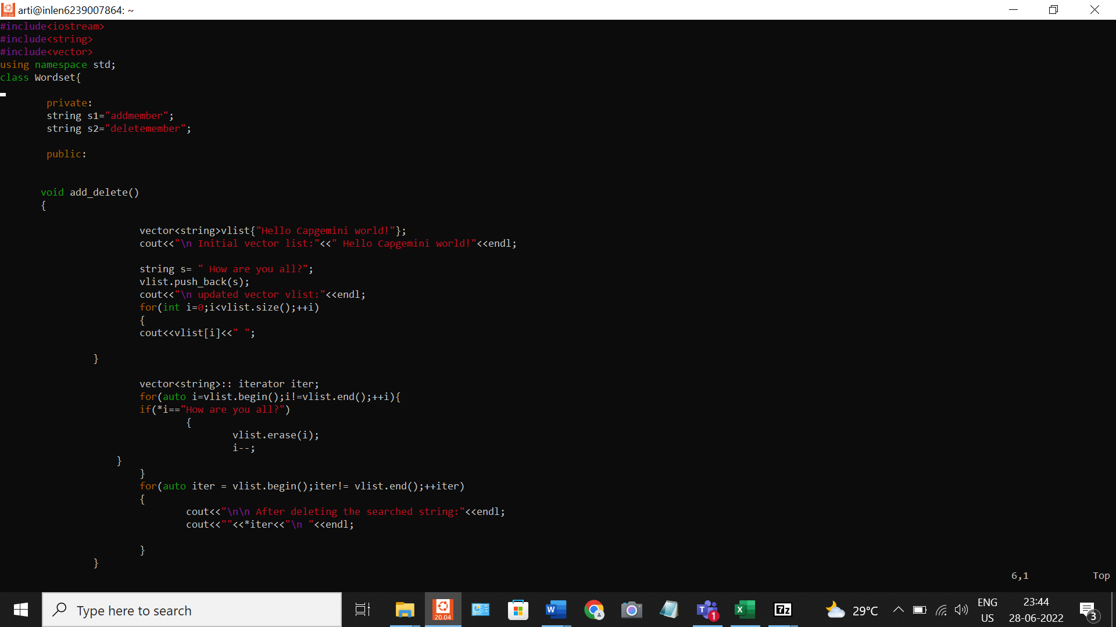

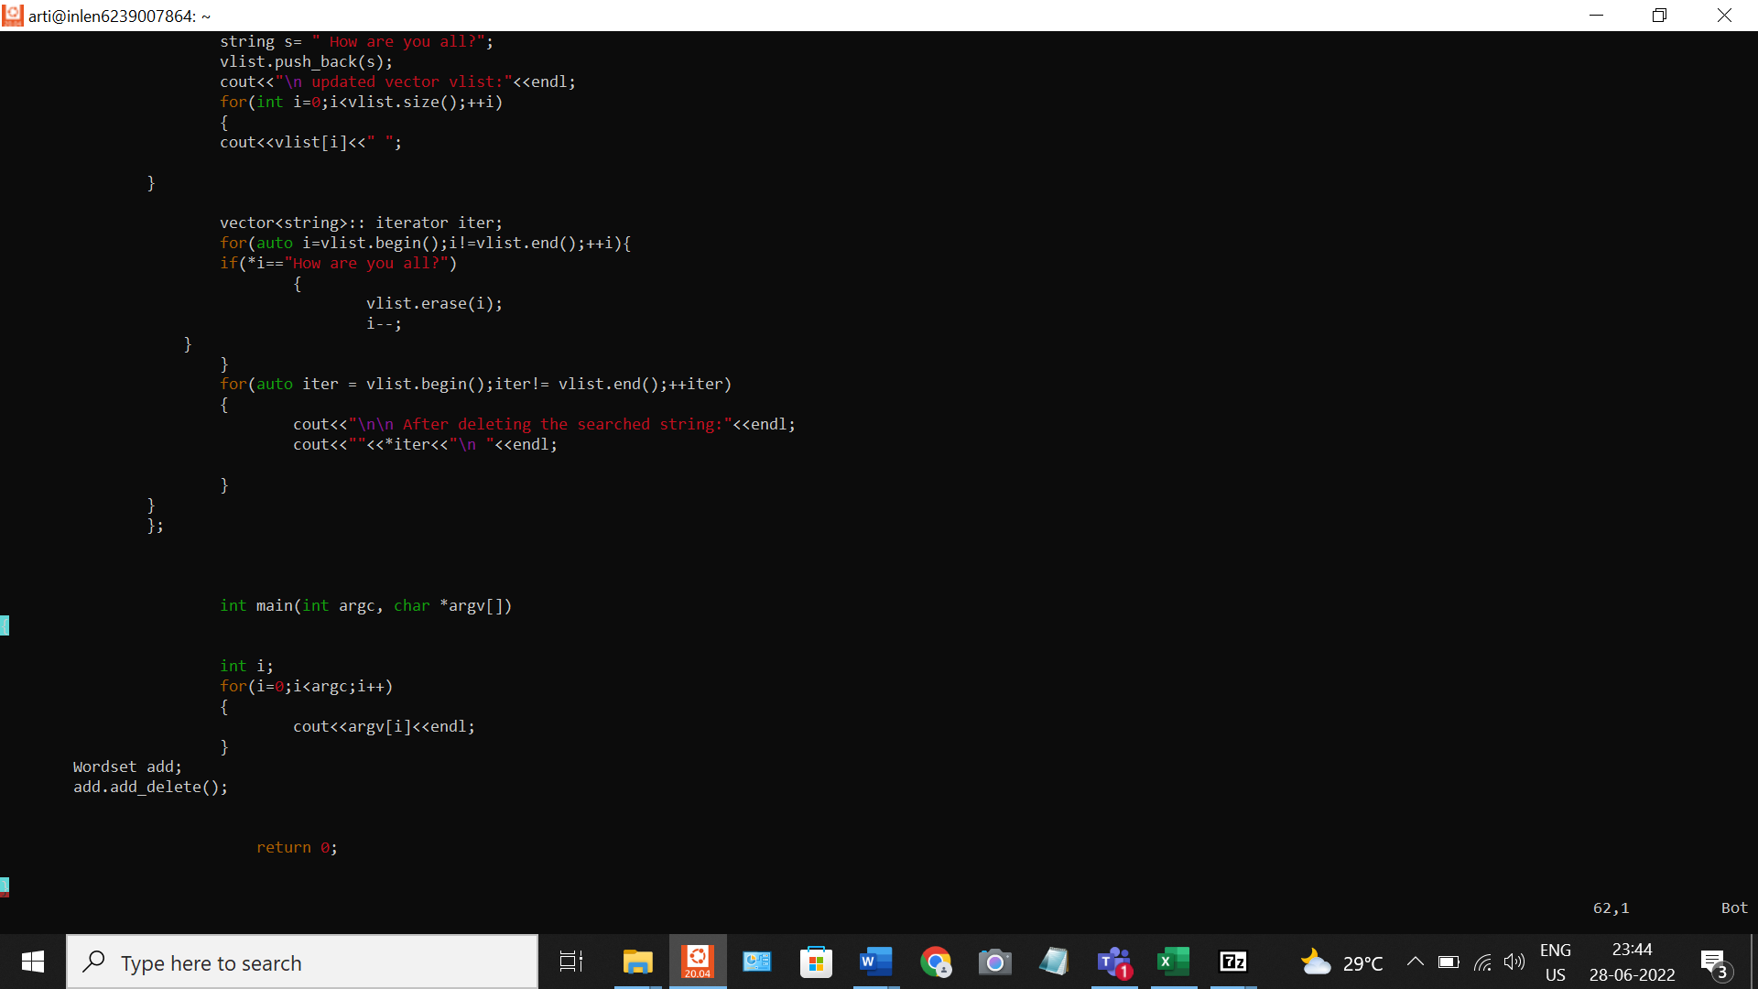

**VSTR/04, VSTR/05, VSTR/06:**

